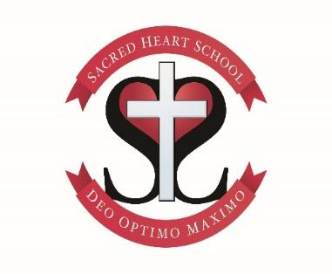

Classroom Teachers
Teaching post 1 – KS2 1.0 FTE (5 days per week)
Teaching post 2 - KS2 0.4 FTE (2 days per week)

Required: September 2021, Fixed term for 1 year
Number on roll: 164
Pay scale: MPS 1-6
The Academy Council is seeking to appoint 2 talented, motivational and inspiring classroom teachers for our school, with additional responsibility for leading a subject area.
Required for September 2021.
We are looking for excellent and experienced classroom practitioners with high expectations for our children, who can support the Catholic ethos of our school. Our dedicated team aim to enable a high standard of education for all our pupils through the teaching, environment, care and opportunities that we offer. Sacred Heart is able to offer the successful candidates a position in Key Stage 2.
The successful candidates should;
- Support the Catholic ethos of our school;
- Be an outstanding practitioner, able to motivate children
- Be innovative, creative and forward thinking;
- Have high expectations of children of all groups and abilities.
- Create a stimulating, well-organised and purposeful learning environment
- Be an ambitious teacher who will care for our children, their learning, faith and well being
- Be a positive role model who will lead by example and form positive relationships within a team

We can offer;
- A strong Catholic ethos;
- A friendly, happy school that lives by its Mission Statement, ‘With Christ at the centre, we show Unity, Respect, Joy, Love, Courage’;
- A happy and supportive team of teachers and support staff
- Well behaved, respectful and happy children who are eager to learn
- Supportive parents, Academy Council and parish community;
- A strong commitment to continuous professional development

Applications are invited from qualified teaching professionals who have the ability to share their enthusiasm, faith, skills and passion for making a difference to learning outcomes.

Practising Catholics are particularly welcome though the position is not exclusive. Candidates would be expected to be sympathetic to the Catholic ethos and actively support our Mission Statement.

Our school is committed to safeguarding and promoting the welfare of our children and expects all staff and volunteers to share this commitment. This post is subject to a satisfactory DSB enhanced disclosure certificate.

Informal visits to our school are warmly welcomed. Please contact Mrs Cheetham, our School Office Manager, to arrange a risk assessed visit. Application forms can be downloaded from the CES website and further details available from school.

Closing Date: Noon, Friday 2nd July 2021
Shortlisting: Friday 2nd July 2021
Lesson Observation and Interview date: Tuesday 6th July 2021

Observations of teaching will be required as well as a formal interview.

